Active Suspension System

A good automotive suspension system should have satisfactory road holding ability.

When the vehicle is experiencing any road disturbance ,the vehicle body should not have large oscillations, and the oscillations should dissipate quickly.

The output should have an overshoot less than 5% and a settling time shorter than 5 seconds.

When the suspension system is designed, a 1/4 model (one of the four wheels) is used to simplify the problem to a 1-D multiple spring-damper system. A diagram of this system is shown below.

This model is for an **active suspension system** where an actuator is included that is able to generate the control force U to control the motion of the bus body.

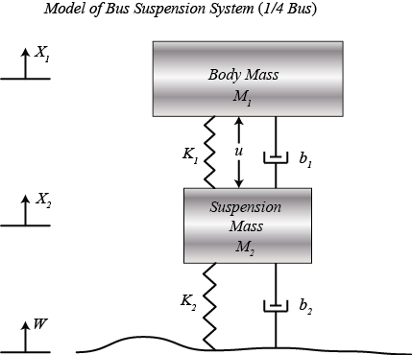

Figure -Model of suspension system

# System parameters

(M1) 1/4 bus body mass 2500 kg

(M2) suspension mass 320 kg

(K1) spring constant of suspension system 80,000 N/m

(K2) spring constant of wheel and tire 500,000 N/m

(b1) damping constant of suspension system 350 N.s/m

(b2) damping constant of wheel and tire 15,020 N.s/m

(U) control force

# Equation

From the picture above and Newton's law, we can obtain the dynamic equations as the following:

For the body mass m1, the equation will form as-

$$m_{1}\ddot{x_{1}}=-b_{1}\left({\dot{x}}_{1}-{\dot{x}}_{2}\right)-k_{1}\left(x_{1}-x_{2}\right)+U$$

For the suspension mass m2, the equation will form as-

$$m_{2}\ddot{x_{2}}=b_{1}\left({\dot{x}}_{1}-{\dot{x}}_{2}\right)+k_{1}\left(x_{1}-x_{2}\right)+b_{2}\left(\dot{w}-{\dot{x}}_{2}\right)+k_{2}\left(w-x_{2}\right)-U$$

# Solver Selection

While solver selection, ode23s and ode45 were giving the desired output. ODE45 solver was chosen as it is a six-stage, fifth-order, Runge-Kutta method. ode45 does more work per step than ode23, but can take much larger steps. For differential equations with smooth solutions, ode45 is often more accurate than ode23. In fact, it may be so accurate that the interpolant is required to provide the desired resolution.

# Output

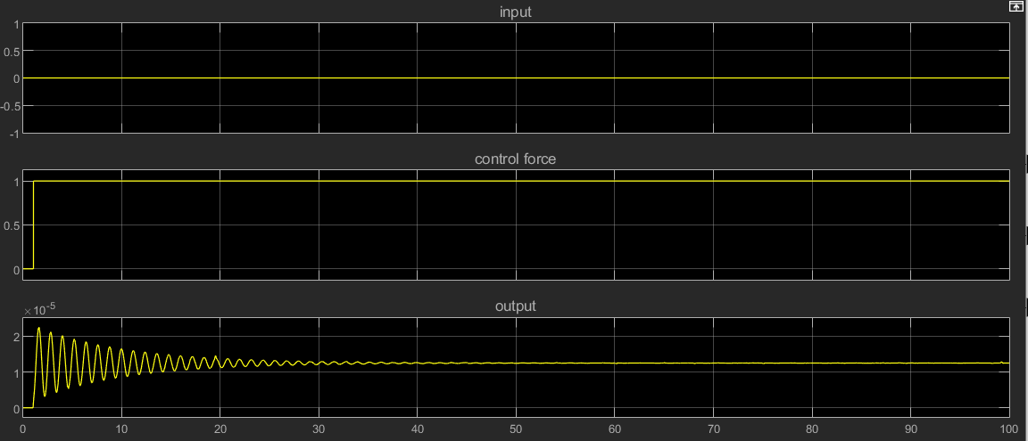

Figure -With the scenario of plain straight road and a step input as a controlling force.

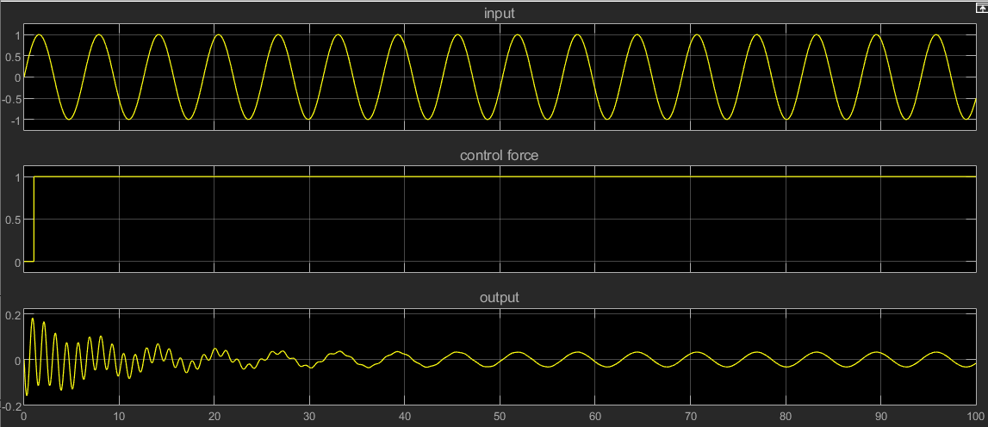

Figure -With the scenario of road full of ups and downs by the help of sine wave input and a step input as a controlling force.